Simple SuperHidden File/Folder Tutorial by
Velerefontis(velerefont@yahoo.com)

Hello fellows!This is my very first tutorial and I hope it wont be disappointing but helpful to you…
The reason I started writing this ,is my belief that everyone has the right of privacy,the right of having files that ONLY HE can act on them.This tutorial is for everyone that wants his files to be seen ONLY by him.I have found some tricks on this subject but none of them worked!Please don’t use my instructions to hide porn material,that’s something I don’t approve of.So,if you agree, continue reading.Last but not least,for any comments,suggestions or questions please email me at velerefont@yahoo.com.

1.Store your folders/files to Recycle Bin.
These are two nice tricks,one of them recently found by me.The other one was in existence but not used in such purpose.
What is Recycle Bin?
Well,Recycle Bin is a hidden system folder.Acting on this ,somehow, differs from acting on other ordinary folder.Its path is c:\Recycled.
Now,since we know its path(c:\Recycled) we can see its attributes using MS-DOS.Type command.com in Start\Run.A DOS window should pop-up.Now type:ATTRIB C:\Recycled.The result must be like that:

In case you don’t know DOS the ATTRIB command is used to see or set the attributes of a file.
S stands for SYSTEM(system file or folder) and
H stands for HIDDEN(hidden file or folder).

The ATTRIB command is used in this way:
ATTRIB +S or -S +H or -H +R or -R +A or –A path+filename/foldername
(A=Archive,R=Read Only)
+ is used to add a property,- is used in the opposite way.
Since the c:\Recycled attributes are S,H goto to DOS and type:ATTRIB -S -H c:\Recycled
Its important not to write –h first and then –s.Properties must be set the way they are given.

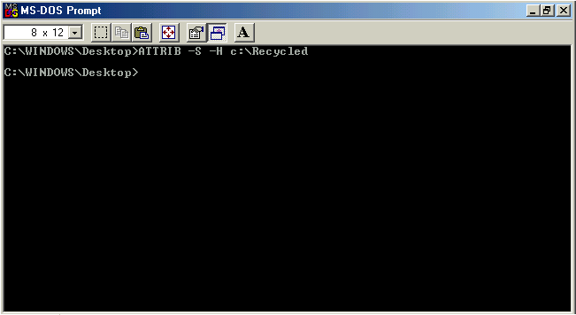

Now goto My Computer\c:\ and press F5 to refresh. You should now see the c:\Recycled folder.Open it and you will see all files that had been previously deleted by you…But they have different names(not extensions)!
You are right,their names are stored in a hidden file named INFO2.If you set folder options to Show Hidden Files/Folders you ll see it.
So why all this crap about Recycle Bin?
Keep reading and you shall see…Now move any file/folder(cut&paste) in c:\Recycled directory.Then run Dos and type:
ATTRIB +S +H C:\Recycled.
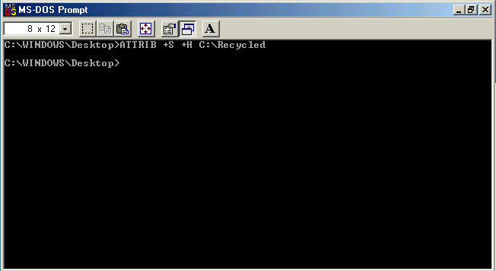
Press F5 to Refresh and that’s it!(c:\Recycled has disappeared and…)
Enter Recycle Bin from Desktop and for sure you wont see your file/folder!!As you have guessed is somehow hidden!
Its also a good idea to set your file’s/folder’s attributes to hidden even when it is in the Recycle Bin, using Right Click\Properties…

Wanna more?Keep reading…

2.Simplest file/folder protection(NOT sure about that,protects you only from amateurs)

Any file/folder can be turned to system folder/file(ATTRIB +S ANYFOLDER) and to hidden folder/file (ATTRIB +H ANYFOLDER).In my computer I used both on a simple file/folder and it became SupperHidden.That means that it cant be seen even if you set Folder Options\Show Hidden Files/Folders.
It can only be viewed like we saw Recycled Bin(using DOS).Now,only the one that knows the folder/file exists and its name can make it visible and act on it(I hope so).No name.no file…

3.The registry Trick(again using Recycle Bin,not sure whether it works in all computers)

I don’t recommend you to read this part if you don’t know what is the registry and how to modify it.Don’t mess with it cause a simple mistake can ruin your data.Please be careful about you are doing and even if you are not ,please try to act as an adult.
The Recycle Bin definion is located in HKLM\Software\Microsoft\Windows\CurrentVersion\explorer\Desktop\Namespace key.There you will see some subkeys that their names are HEX numbers & characters inside “{ }”.One of them has as Default value Recycle Bin or something similar.It must look like that:
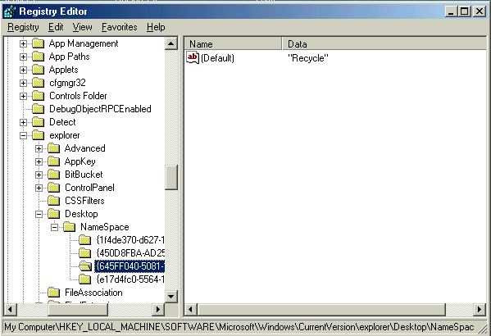
If you delete that key Recycle Bin is deleted.You can restore it by recreating that key and writing its name exactly as it was({Hex numbers,letters}).But Recycle Bin’s contents wont be deleted anyway.So you can send a file/folder to Recycle Bin by deleting it and then delete Recycle Bin using Registry.When you restore it again using Registry the file/folder will be there! I suggest you to use that only if REALLY need to hide something cause its very tiring.
Trick:Write down the name of the key so that you can recreate it easily.
Tip:1.In many computers such as mine if you delete/recreate the Recycle Bin key you must restart Windows to see the difference.
2.Other files/folders deleted while Recycle Bin does not exist,are completely deleted despite the same old windows deletion message.
3.Advice given in this tutorial can also be used to SECURE files/folders.

So that’s it!I hope you have enjoyed it!Have a nice time hiding your files!
For ANY comments,suggestions or questions etc. please e-mail me at velerefont@yahoo.com

Written by Velerefontis.
Dedicated to ela bellla!

.

