How to Change Sounds in Trillian
A short walk-thru by: Lankylurkr

A friend of mine and I were chatting on Trillian the other night and our discussions ventured to the sounds that ship standard with the program. After some cursory examination, I discovered that the Trillian sounds cannot be accessed by easy means. (i.e. sounds in the control panel).
On further inspection, I discovered where and how to change the sounds, which I will now tell you (with pictures too!)

- Go into windows explorer, and double-click (or single if you’ve got that web enhanced b.s.) local disk.

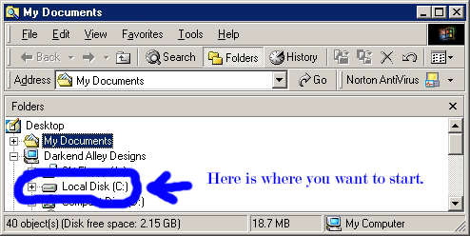

- Once you’ve opened your local disk, you get a list of all the folders found in your C: drive (I use the term c: drive because it’s easy. Wherever you have your program files folder is the drive you need to be.) Now we want to cruise on down to the program files folder.

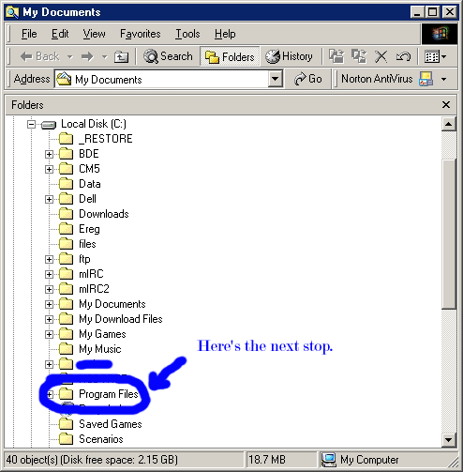

- o.k., double click on the program files folder and watch your file tree get a heck of a lot longer. We’re going to be looking for the Trillian file folder.

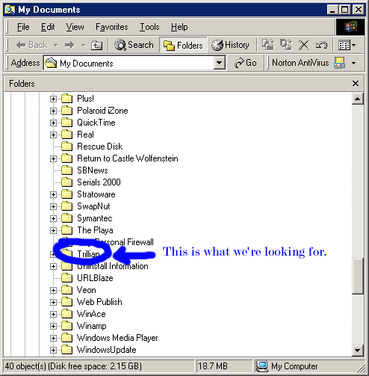

- After double clicking on the Trillian folder, we get a couple of sub folders. The folders are skins and users. You would think that the sound folder would be in the users folder, but no, it’s not that easy.

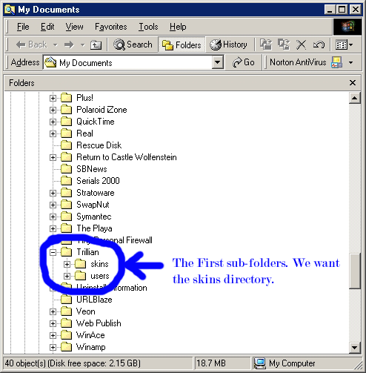

- Once we have gotten into the skins folder, we notice that there is only one folder. Double click on it.

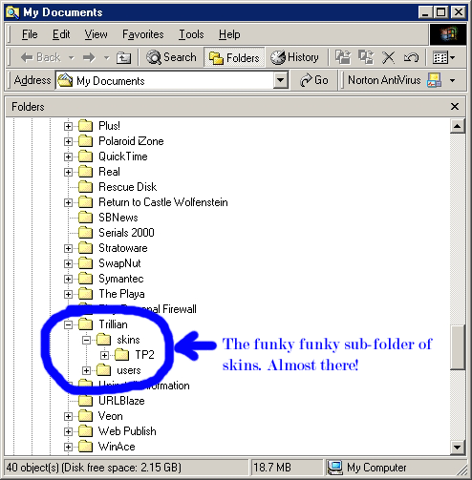

- Double click the TP2 file, and this will open up some more files and folders. If you look closely enough, you’ll see there is a sounds folder. Double click that one.

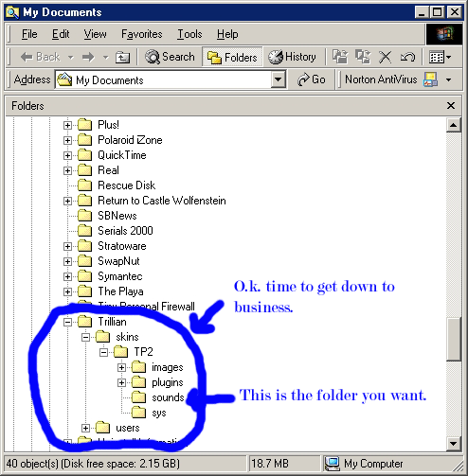

- Now we’re in the sounds folder, we need to find two files. The first file is
message-inbound.wav. (this file plays whenever you get a message) The second
sound file is message-outbound.wav. (this file plays whenever you send a message.)

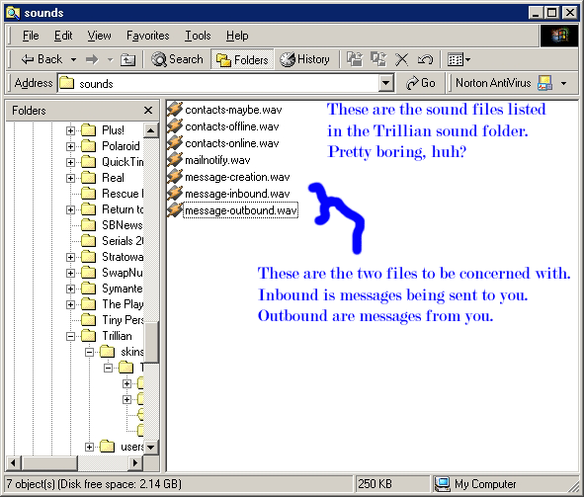

- Now what we want to do is change the names of the original files to a backed up name. For this example, we’ll change the files to message-inbound_1.wav and message-outbound_1.wav. This will prevent Trillian from playing those sounds. Now, we’re going to change the wav files from their original names (what ever they were) to message-inbound.wav (for the sound you want to play on receiving a message) and message-outbound.wav (for the sound you want to play when you send a message. For best results, I suggest you use sound files under 30k, or else they might not work well. In fact, 20k or below would be optimum. But YMMV.

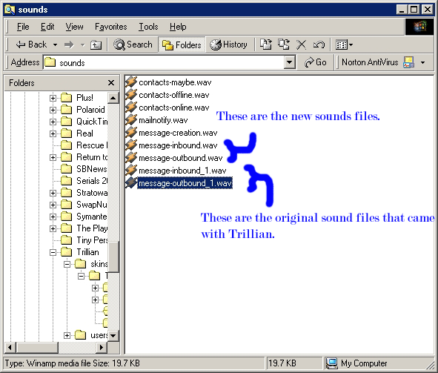

As a side note, I’ve used sound clips from Monty Python. The ‘Message for you sir’ from Search For The Holy Grail. And ‘Don’t do it!’ from Flying Circus.

Good Luck and have fun!

Lankylurkr
02.05.2002

