Worldgroup 3.1
A full featured connectivity solution. Accessible through the web (thin client), client/server (thick client) or ANSI/ASCII (text only)
Adaptec
United Telecom/US Sprint
Hawaii State Bar Association
US Air Force
New York Power Authority
Citibank
Office Depot
AT&T
University of Florida
Ericsson GE
Archdiocese of Chicago
Hewlett Packard
Ministry of Revenue (Canada)
Fulton Bank of PA
United Nations
Egghead Discount Software
Novell
City of Seattle
Mobil Oil Corporation
Intel
Girl Scouts USA
Cellular One
Ralston-Purina
US Department of Transportation
Holiday Inn, Inc.
University of Wyoming
Motorola
Federal Bureau of Prisons
Boca Research
National Weather Service
The Hartford Courant
CompuServe, Inc.
Internal Revenue Service
US Army
General American Life
Dell Computer Corp.
Xerox
ZyXel Service
The Programmer’s Shop
Texas Parks & Wildlife Depart.
General Electric
Blue Cross/Blue Shield
Citicorp
Dun & Bradstreet
Baltimore Gas & Electric
America Online
Ohio College of Medicine
Teleflora Creditline
National Association of Realtors
GTE
Nestle Corporation

Take your site beyond incomplete “page hit” auditing. User accounts bring demographic data, usage information and access control to your Web site. Generate real mailing labels – as well as e-mail distribution lists – for direct marketing campaigns.

Conduct surveys to gather meaningful information about those visiting your site. Track system and user activities with the built-in audit trail – you can configure which events are recorded and product reports for further analysis.
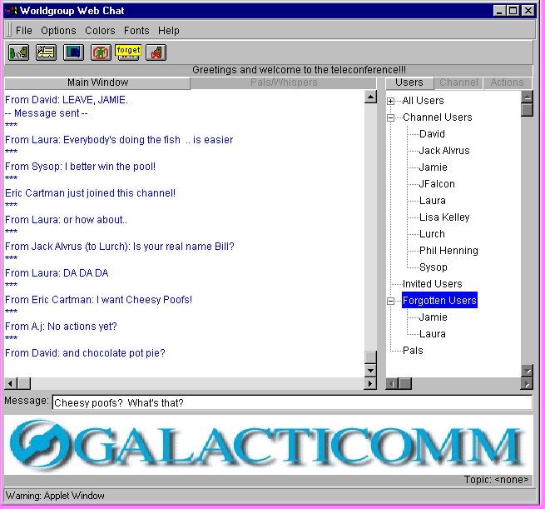
Automatically grant access to information and features based on who the user is. Our proven User Management system using our Locks and Keys technology determine how each user will view or access information and applications. Set up security keyrings, time restrictions, options for billing and expiration dates for individual users or classes of users.

Includes:
- Local & Internet E-mail
- Chat Rooms with shared White Board
- Shared file libraries
- Threaded discussion forums
- Customizable surveys
- IRC Client
- ftp, telnet, finger, POP3 800-328-1128
- Built in web server

Technical Information

General/User Interface Features
- Accessible through the web, client/server or terminal mode
- Freely distributable client software for Windows 95/98/3.x
- ASCII/ANSII interfaces available for non-client users
- Multi-user chat with: 65,535 channels, white board, with full color palette, one-on-one chat, many to many chat, page, whisper, moderators, activity-scan, real time file transfer while in chat.
- Polls and Questionnaires facility with online report generator
Maximum number of polls/questionnaires: up to size of disk
Maximum number of questions per poll/questionnaire: 100
- Registry of Users (Template is configurable by Administrator)
- Year 2000 Compliant

Performance and Architecture
- Communications architecture supports simultaneous COM1/2/3/4
- Connectivity methods: TCP/IP, Modem, Serial, SPX
- Maximum add-on options: limited by memory/disk space available
- User data and message files are Btrieve-based for power-fail integrity

Minimum Hardware Requirements

OS | Server | RAM | Disk Space
Windows NT | Pentium 100 | 64MB | 300MB
Windows 95 | Pentium 100 | 32MB | 300MB

User Account Management
- Maximum number of user accounts: Limited by disk space
- Maximum number of user “classes”: 10,000
- Maximum User-ID length: 29 alpha/digit/punctuation characters
- Password length: 3 - 9 characters
- User information fields for: name, company, address (2 lines), country, voice phone, computer type, date of birth, sex, User-ID and password
- Utility to generate mailing labels for user accounts
- Statistical analysis of line use, demographics, class activity, module usage
- User Management give total access control to all areas of the system
- Famous Locks and Keys technology provides unbeatable User Management
- Audit trail entries can be recorded for almost any function
- Three levels of profanity suppression with configurable profanity dictionary

Security and Menu Control
- Maximum number of keys per user class: 1,000
- Maximum number of individual keys per user: 1,000
- Possible “access level” combinations: over 100 billion
- Maximum number of menu pages: 10,000
- Maximum number of options per menu page: 25
- Menu options can: display a text file, go to another menu or call built-in or add-on functions of the system
- Maximum number of text variables in a menu display: 256
- Route users to different menus based on their keys or channel
Messaging capabilities (E-mail and Forums)
- Maximum message text length: 16,000 bytes
- Maximum number of messages with attachments : 2 billion
- Maximum “attachment” file size: up to available disk space
- Maximum number of Threaded discussion (forums) groups: 65.000
- Maximum number of Administrator-defined distribution lists: 2,340
- Maximum number of names in the Administrator-defined distribution lists: up to available disk space
- Support for Internet addresses in distribution lists
- Global and personal distribution lists
- Security levels (per user per forum): invisible, read, download, write, upload, Co-op, Forum-op, Sysop
- Automatic chat room for each forum
- Read forum messages chronologically or by threads
- Forums can be local, networked, or available to browsers on the Internet, or any combination
- Multi-level forum grouping
- User configurable “Quickscan” for simple access to favorite forums
- Users can auto-forward mail to another user account or an Internet address
- Message forward/copy with comments, carbon copies, return receipts, file attachments, keyword searching, message quoting capabilities, in box, out box, address book, multi-foldered filing cabinet, priority and new message flags
- Users can send/receive messages with attachments locally or via the Internet
- Independent charges for each mail function: read, write, download, upload, return receipt, priority
- Independent auditing for each message read, written, attachment upload/download, forum creation/deletion, etc.
- Can reply and read messages off line with client
- RTF color and font support with client
File Library and Upload/Download Capabilities
- Maximum number of file areas: up to available disk space
- Maximum number of files in each file area: up to available disk space
- Upload/download protocols: ZMODEM, YMODEM-G, YMODEM-Batch, XMODEM-IK, XMODEM, Kermit, Super Kermit, ASCII
- Maximum length of file descriptions: up to 15 lines, 49 bytes per line
- File tagging (up to 999 files per user)

